**SQL Assignment – 2**

Q – 1: Create a stored procedure in the Northwind database that will calculate the average value of Freight for a specified customer.Then, a business rule will be added that will be triggered before every Update and Insert command in the Orders controller,and will use the stored procedure to verify that the Freight does not exceed the average freight. If it does, a message will be displayed and the command will be cancelled.

Query :

CREATE PROCEDURE spInsertInOrdersHarshil

@customerID nchar(5),

@EmployeeID int,

@OrderDate datetime,

@RequiredDate datetime,

@ShippedDate datetime,

@ShipVia int,

@Freight money,

@ShipName nvarchar(40),

@ShipAddress nvarchar(60),

@ShipCity nvarchar(15),

@ShipRegion nvarchar(15),

@ShipPostal nvarchar(10),

@ShipCountry nvarchar(15),

@type nchar(10)

as

begin

if @type = 'insert'

if @Freight < (select avg(Freight) from Orders)

INSERT INTO Orders VALUES (@customerID ,@EmployeeID ,@OrderDate ,@RequiredDate ,@ShippedDate ,@ShipVia ,@Freight ,@ShipName ,@ShipAddress ,@ShipCity ,@ShipRegion ,@ShipPostal ,@ShipCountry )

else

print 'Given Freight Value exceeding the average Freight Value'

else if @type = 'update'

if @Freight < (select avg(Freight) from Orders)

update Orders set Freight = @Freight where CustomerID = @customerID and OrderDate = @OrderDate

else

print 'Given Freight Value exceeding the average Freight Value'

end

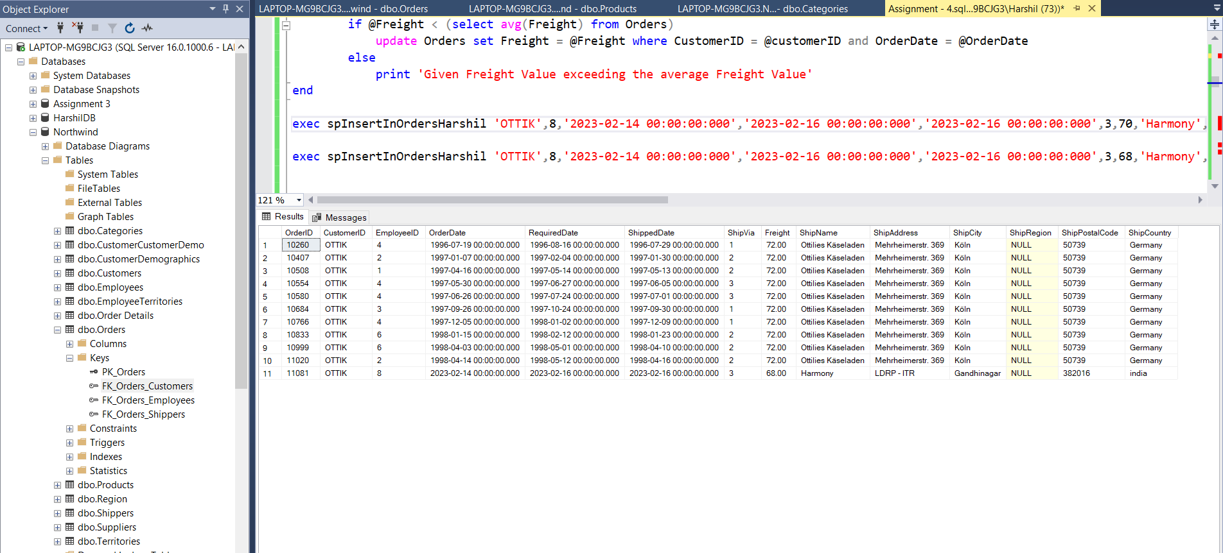

Q – 2 : write a SQL query to Create Stored procedure in the Northwind database to retrieve Employee Sales by Country.

Query : CREATE PROCEDURE spEmployeeSalesByCountry

@Country nchar(50)

AS

BEGIN

SELECT e.FirstName,e.LastName,o.ShipCountry,od.Subtotal AS SALES FROM Employees e LEFT JOIN Orders o ON e.EmployeeID = o.EmployeeID RIGHT JOIN [Order Subtotals] od ON od.OrderID = o.OrderID where ShipCountry = @Country group by e.FirstName,e.LastName,o.ShipCountry,od.Subtotal

END

drop proc spEmployeeSalesByCountry

exec spEmployeeSalesByCountry 'Argentina'

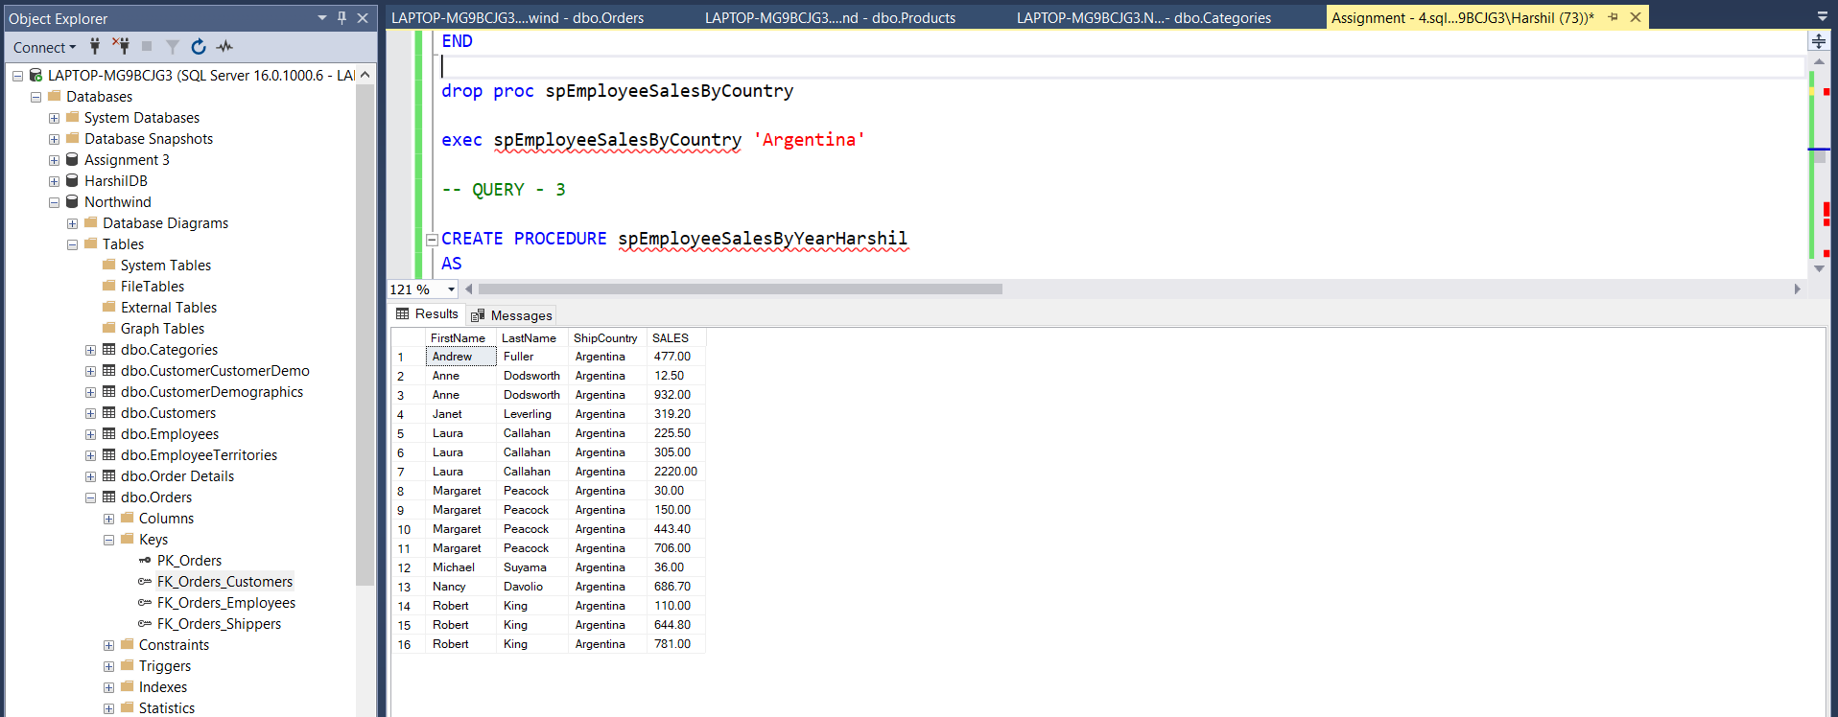

Q – 3 : write a SQL query to Create Stored procedure in the Northwind database to retrieve Sales by Year.

Query : CREATE PROCEDURE spEmployeeSalesByYearHarshil

@Year int

AS

BEGIN

SELECT YEAR(o.ShippedDate) as 'Year',o.OrderID,od.Subtotal as 'sales' FROM Orders o JOIN [Order Subtotals] od ON o.OrderID = od.OrderID where YEAR(ShippedDate) = @Year group by YEAR(o.ShippedDate),o.OrderID,od.Subtotal

END

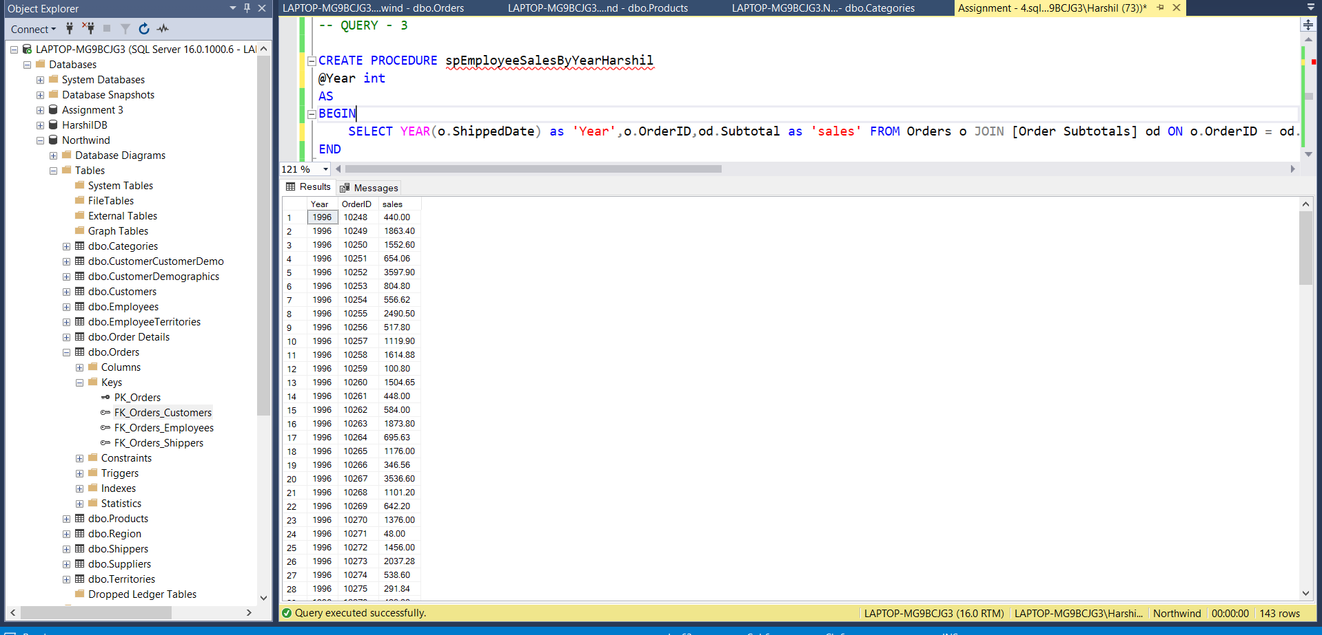

Q – 4 : write a SQL query to Create Stored procedure in the Northwind database to retrieve Sales By Category .

Query : CREATE procedure prSalesByCategoryHarshil

@CategoryID int

as

begin

select c.CategoryID, c.CategoryName as [Category], count(o.OrderID) as [Total Orders] from Categories c

join Products p on c.CategoryID = p.CategoryID

join [Order Details] o on p.ProductID = o.ProductID

where c.CategoryID = @CategoryID

group by c.CategoryID, c.CategoryName

end

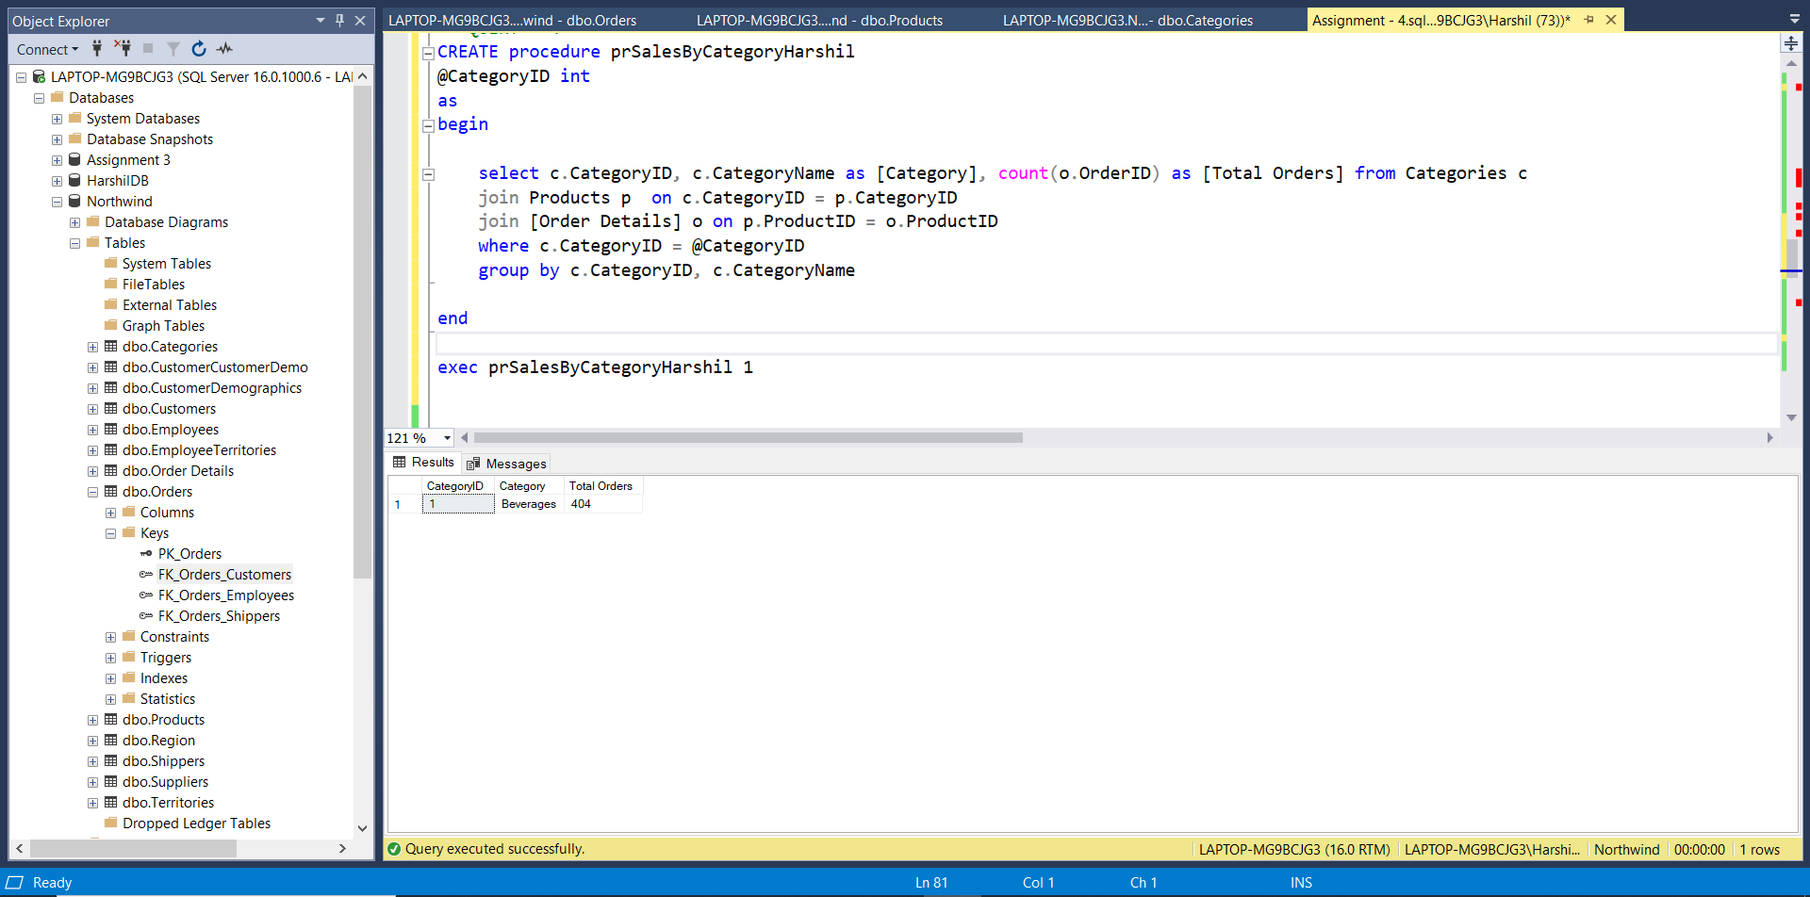

Q – 5 : write a SQL query to Create Stored procedure in the Northwind database to retrieve Ten Most Expensive Products .

Query : CREATE PROCEDURE spToptenExpensiveProducts

AS

BEGIN

select top 10 ProductName,UnitPrice from Products order by UnitPrice desc

END

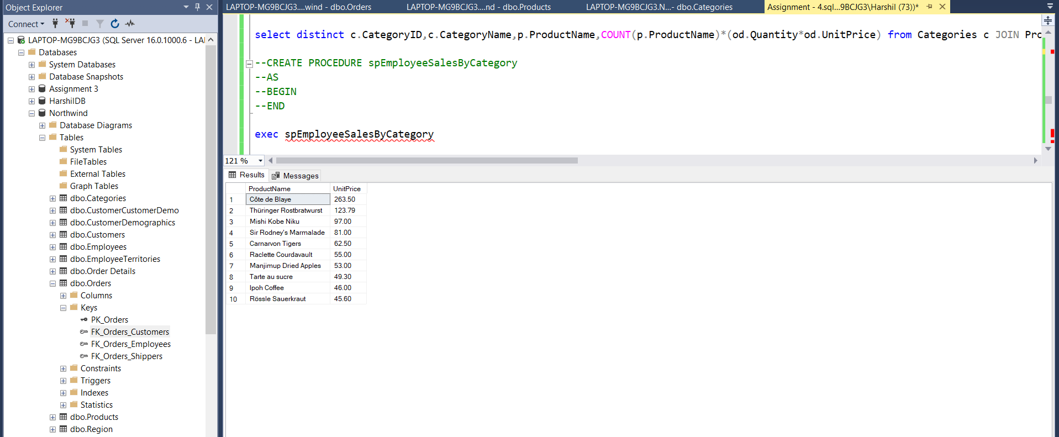

Q – 6 : write a SQL query to Create Stored procedure in the Northwind database to insert Customer Order Details.

Query : CREATE PROCEDURE spInsertIntoCustomerDetails

@OrderID int ,

@ProductId int,

@UnitPrice float,

@Quantity int,

@Discount float

AS

BEGIN

INSERT INTO [Order Details] VALUES (@OrderID, @ProductId,@UnitPrice,@Quantity,@Discount)

END

EXEC spInsertIntoCustomerDetails 10250,49,50.50,10,0

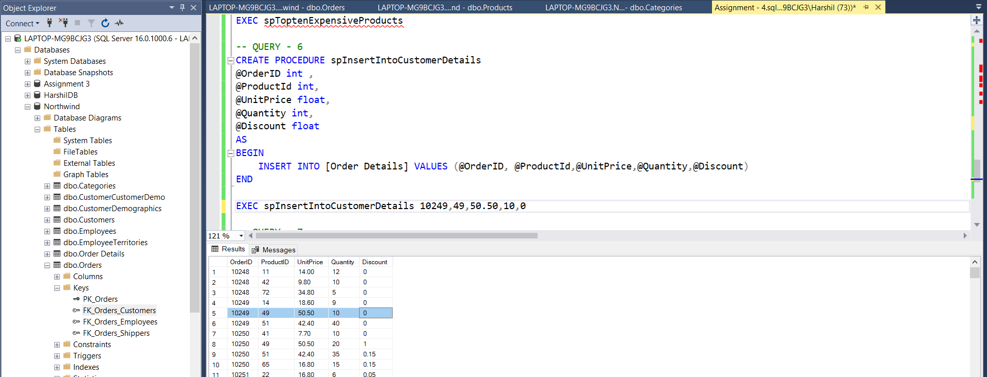

Q – 7 : write a SQL query to Create Stored procedure in the Northwind database to update Customer Order Details .

Query : CREATE PROCEDURE spUpdateCustomerOrderDetails

@ProductId int,

@Quantity int,

@Discount float

AS

BEGIN

UPDATE [Order Details] SET Discount = @Discount,Quantity = @Quantity where ProductID = @ProductId

END

EXEC spUpdateCustomerOrderDetails 49,20,1

